ADF ASSIGNMENT
1) Create a container in ADLS with the project name as sales_view_devtst
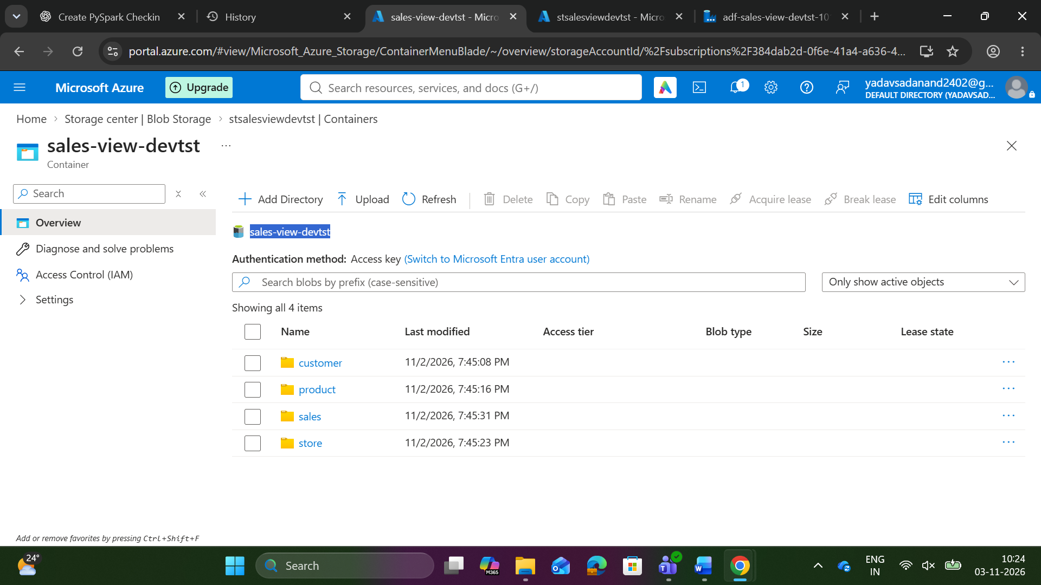

2) Create an ADF Pipeline to get the latest modified files the folders of the ADLS
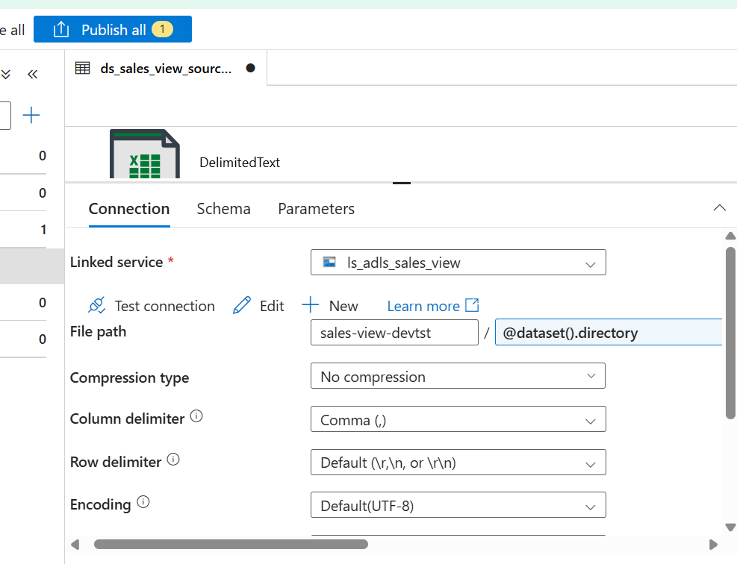
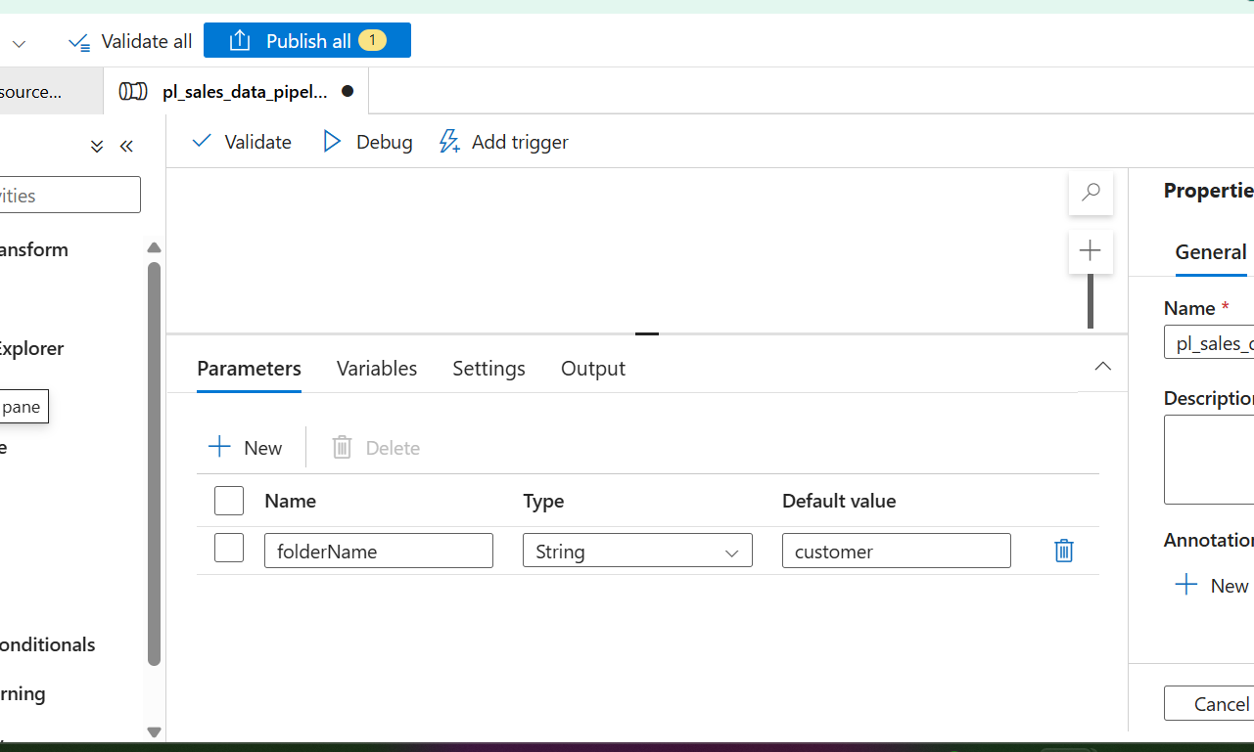
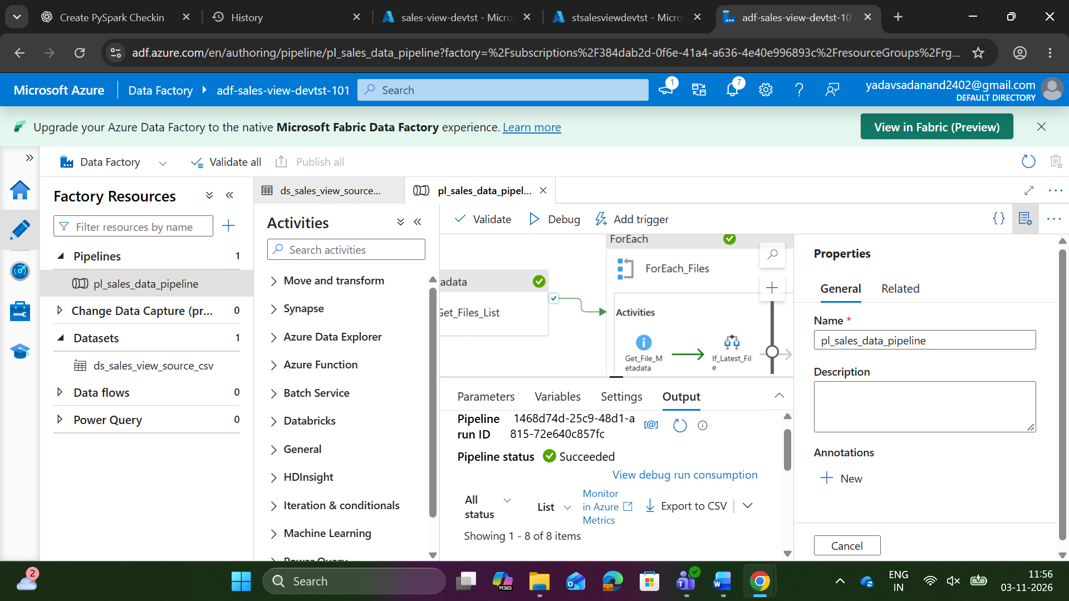
3. Create a Bronze/sales view/ (Bronze – container)
Subfolders-> customer, product, store, sales, and store the raw data copied from the ADF pipeline
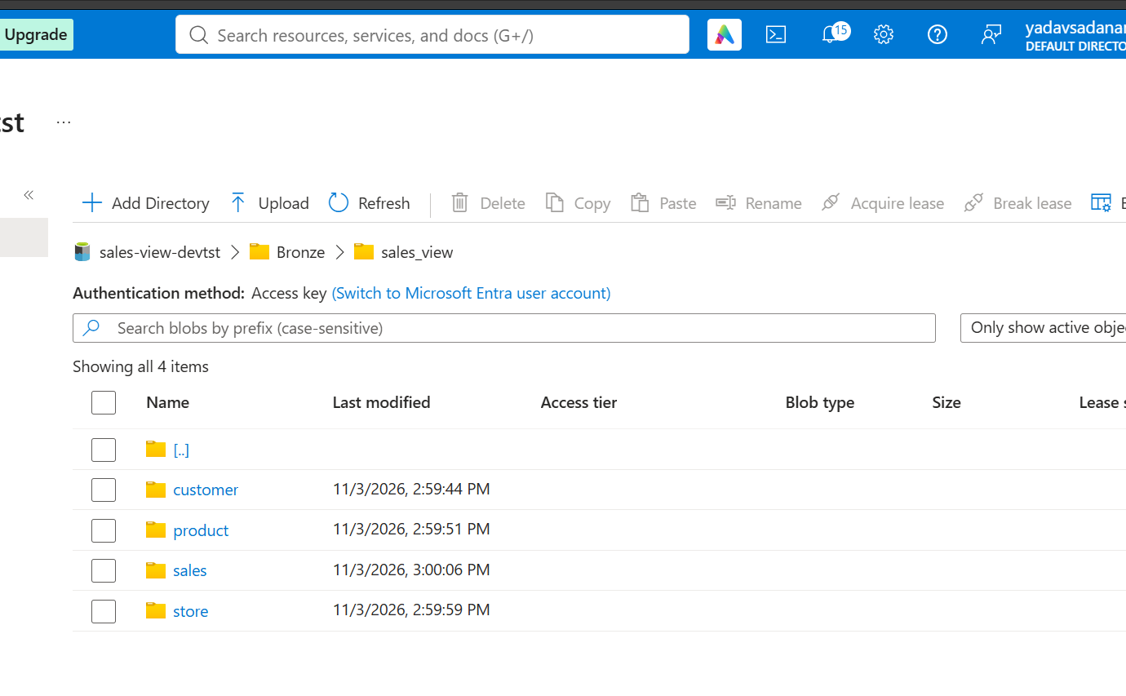
4. Customer file
All the column headers should be in snake case in lower case (By using UDF function dynamically works for all camel case to snake case)
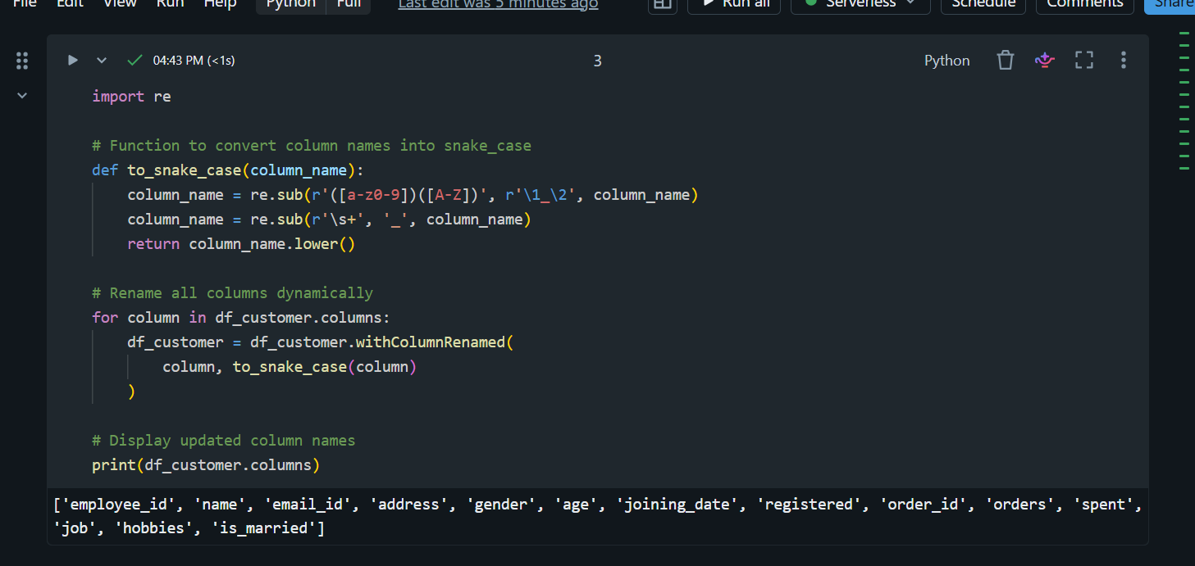
- By using the "Name" column split by " " and create two columns first_name and last_name
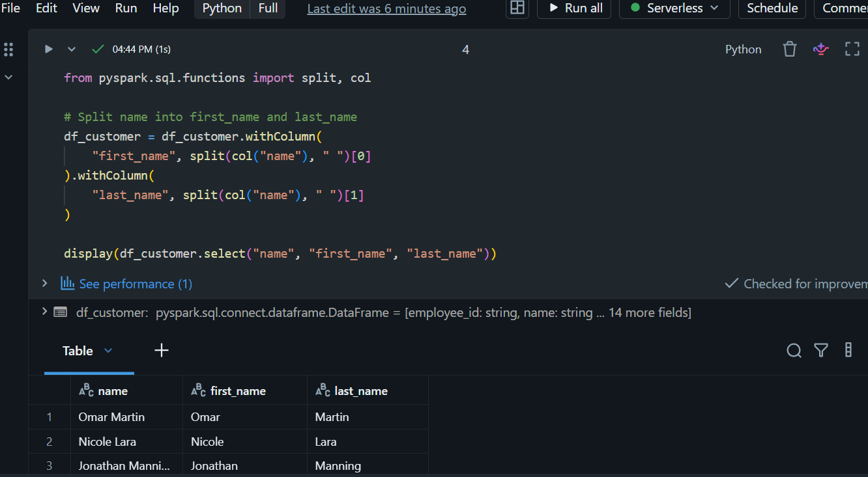
- Create column domain and extract from email columns Ex: Email = "josephrice131@slingacademy.com" domain="slingacademy"
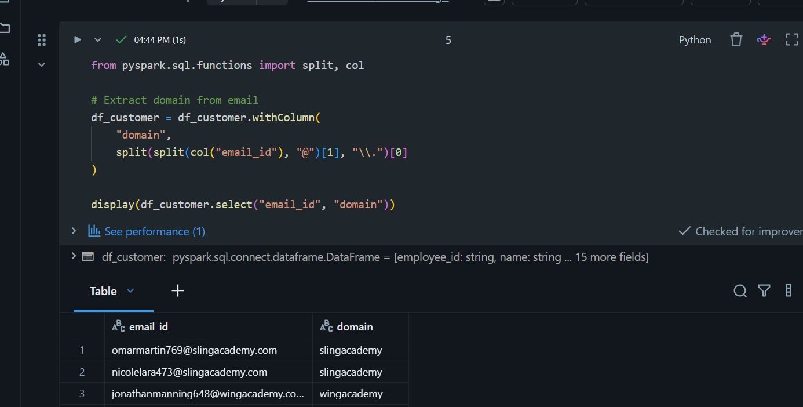
- Create a column ‘gender where male = "M" and Female="F"
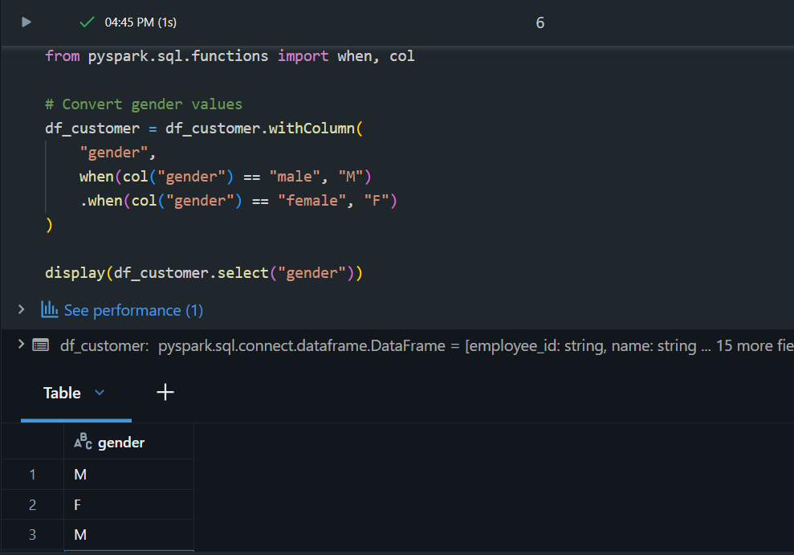

- From Joining date create two columns date and time by splitting based on " " delimiter.
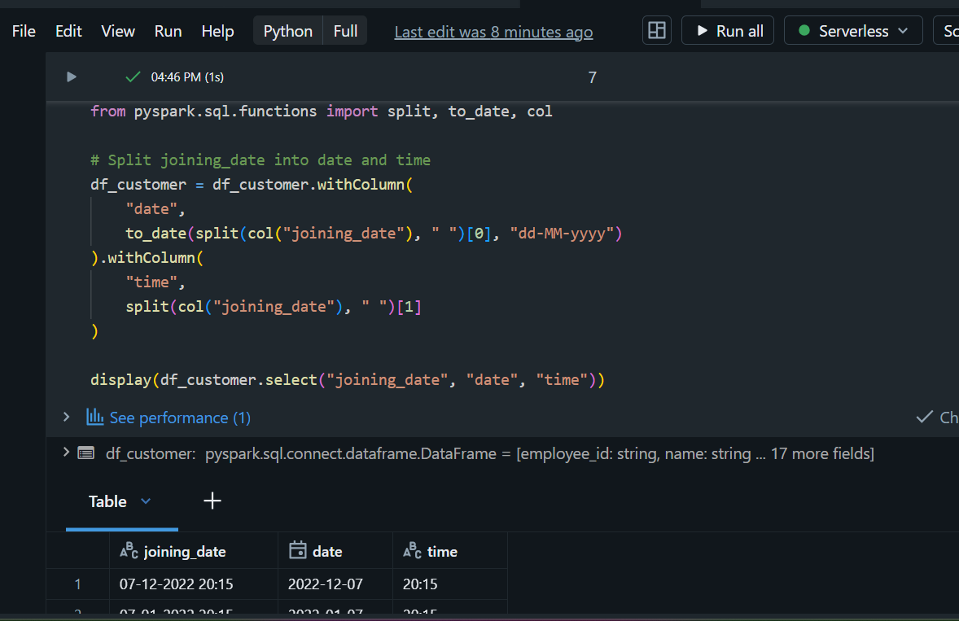
Create a column expenditure-status, based on spent column is spent below 200 column value is "MINIMUM" else "MAXIMUM"
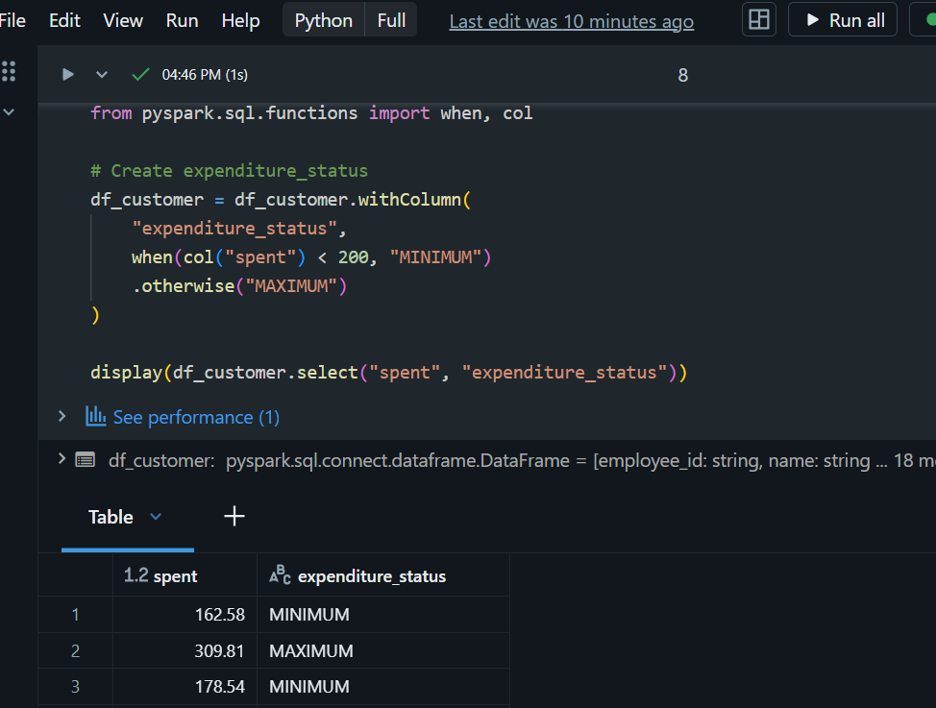
Write based on upsert [table_name: customer] (in silver layer path is silver/sales_view/tablename/{delta pearquet}
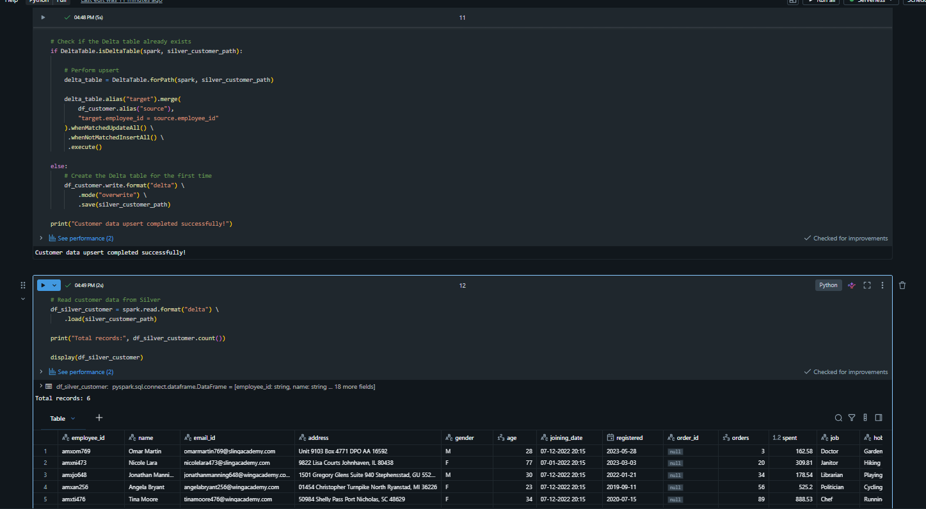
- 5. Product File
All the column header should be in snake case in lower case (use same UDF Function)
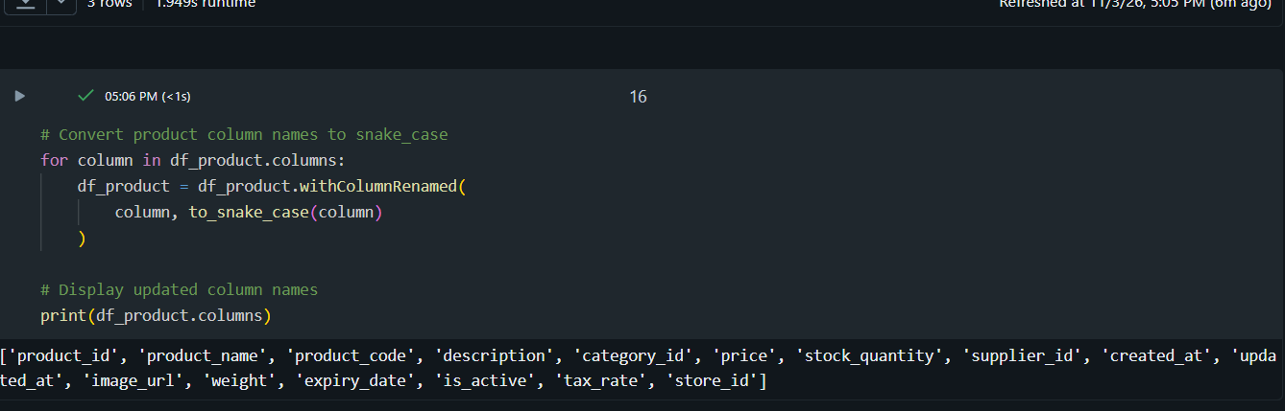
- Create a column sub_category (Use Category columns id category_id=1, "phone"; 2, "laptop"; 3,"playstation"; 4,"e-device"
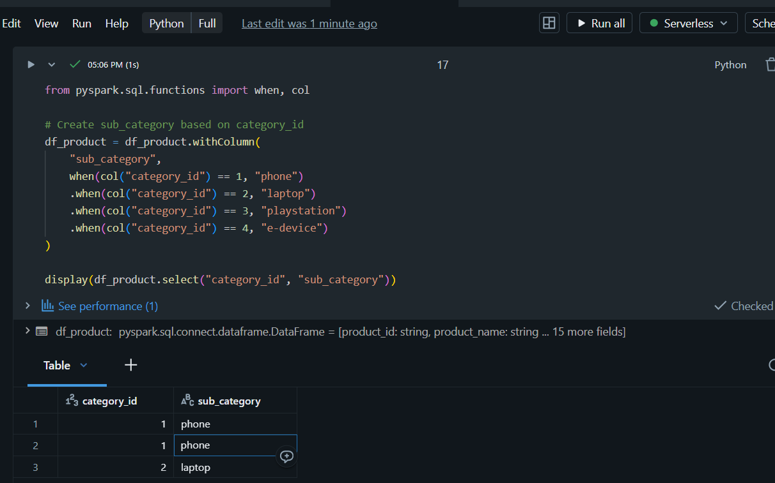
- Write based on upsert [table_name: product](in silver layer path is silver/sales_view/tablename/{delta pearquet}
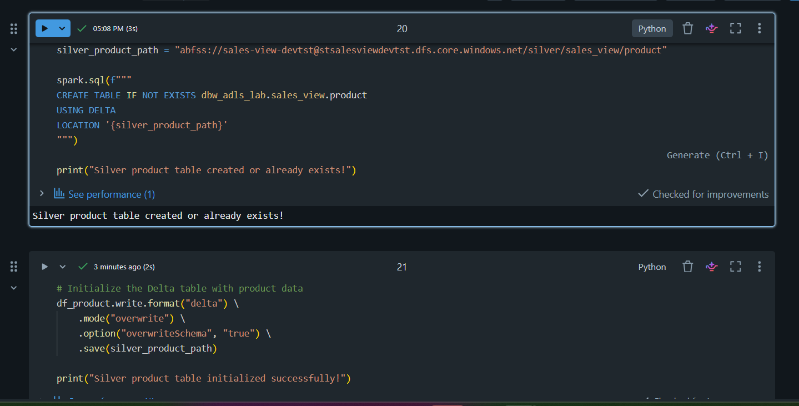
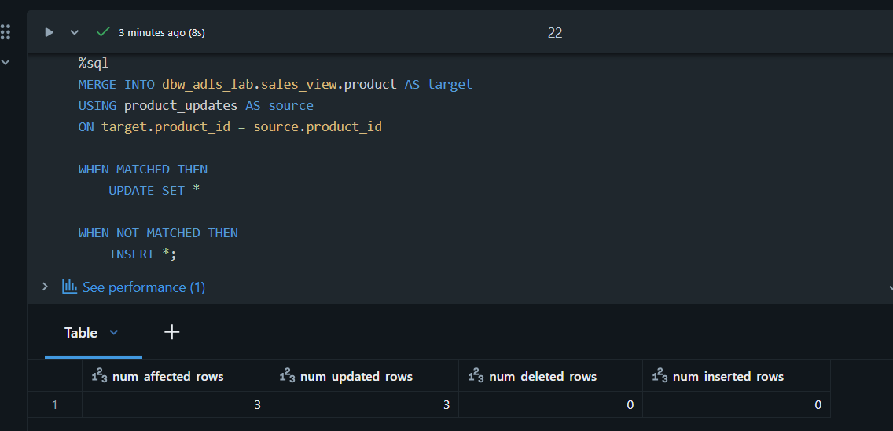
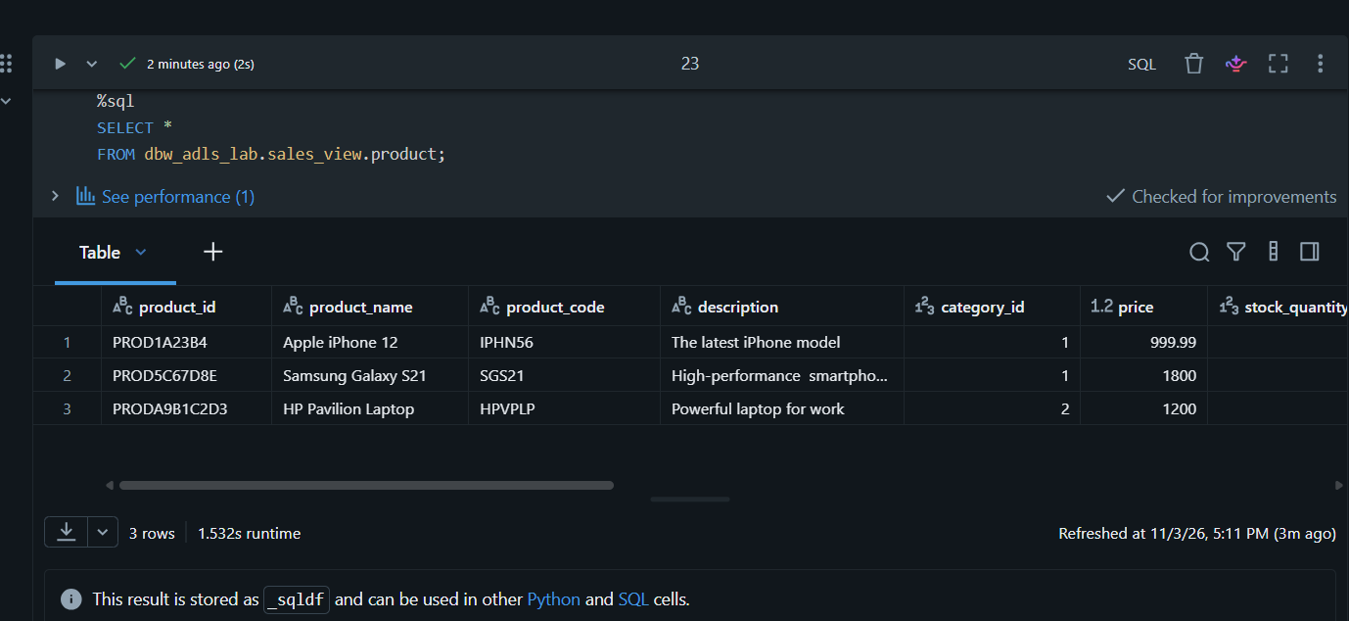

6. Store
- Read the data make sure header should be in snake case in lower case (use same UDF Function)
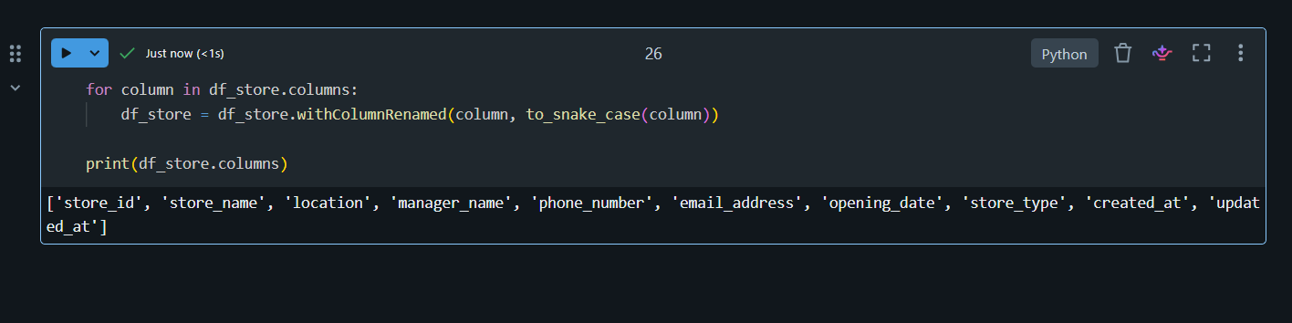
- Create a store category columns and the value is exatracted from email Eg: "electromart" from johndoe@electromart.com
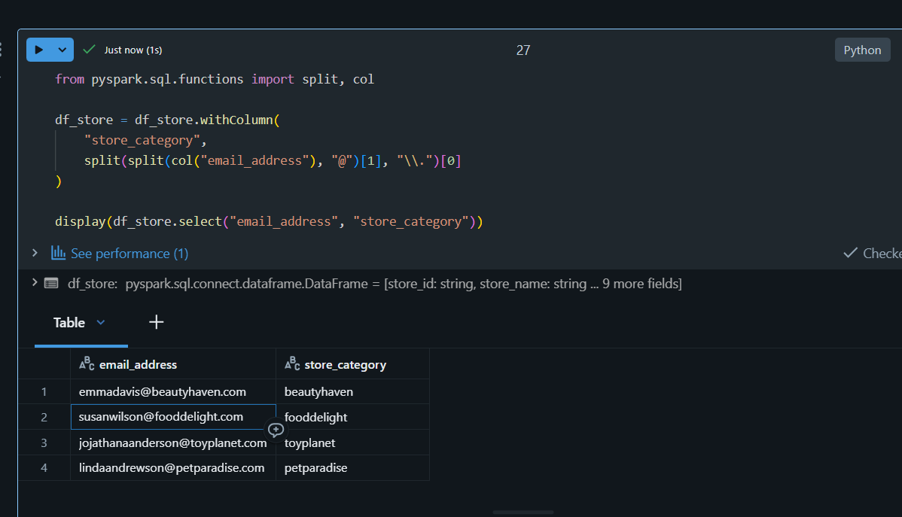
- created_at, updated_at date as yyyy-MM-dd format
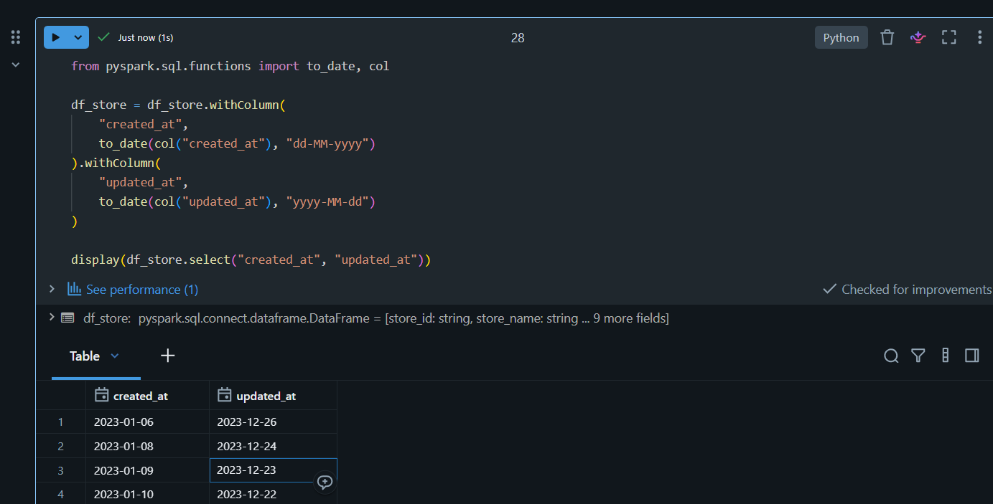

- Write based on upsert [table_name: store] (in silver layer path is silver/sales_view/tablename/{delta pearquet}
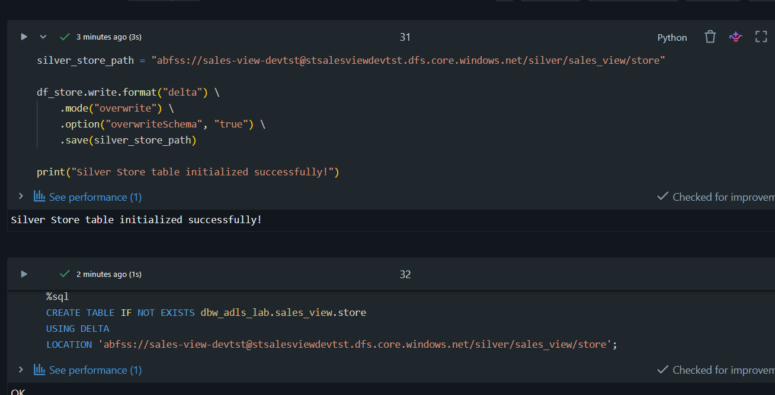
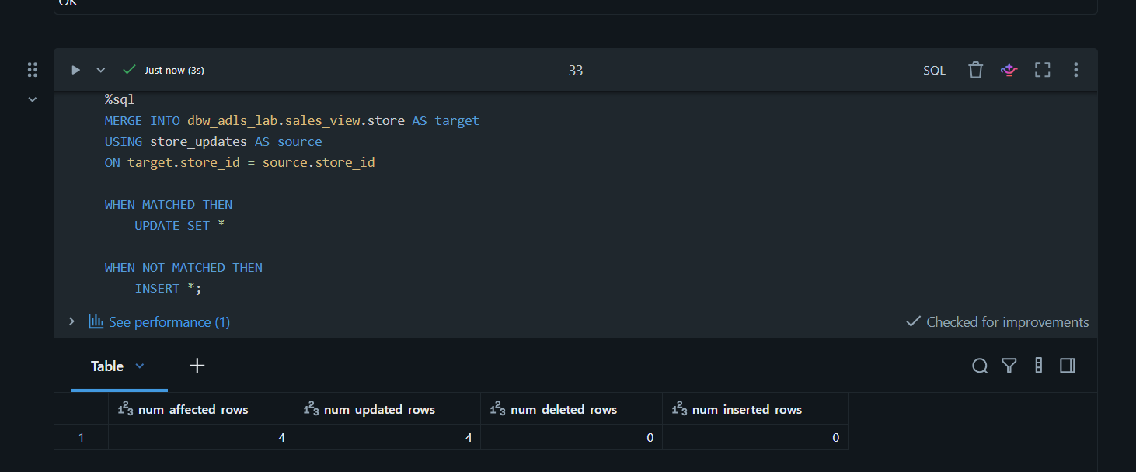
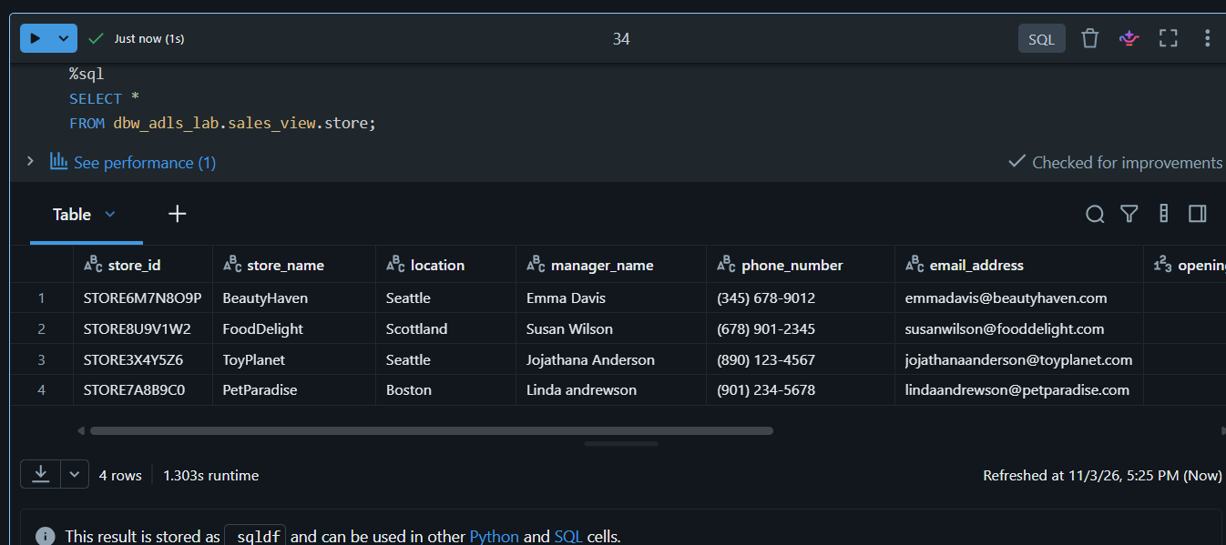

7. Sales
- Read the data make sure header shlould be in snake case in lower case (use same UDF Function)
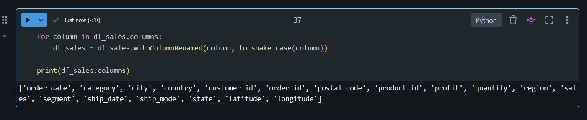
- Write based on upsert [table_name: customer_sales] (in silver layer path is silver/sales_view/tablename/{delta pearquet}
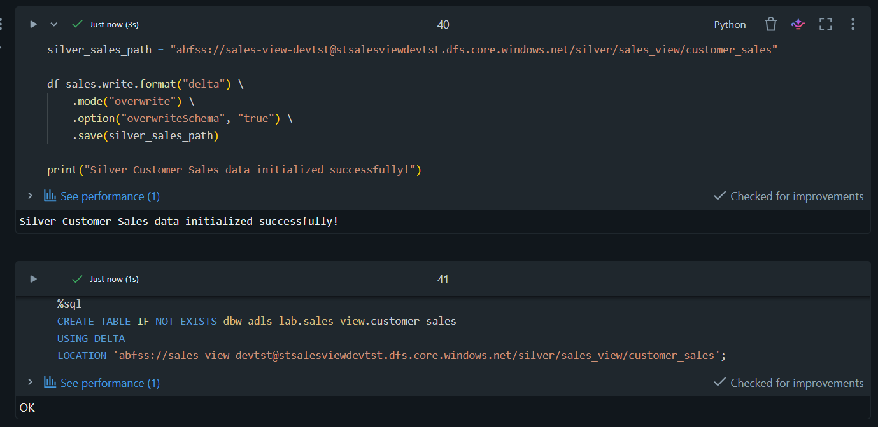
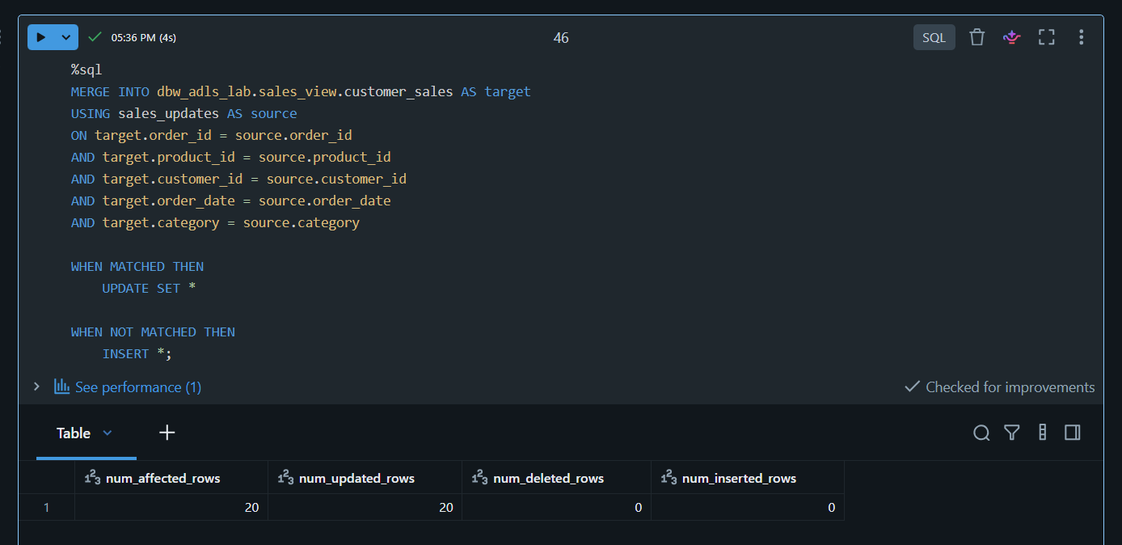
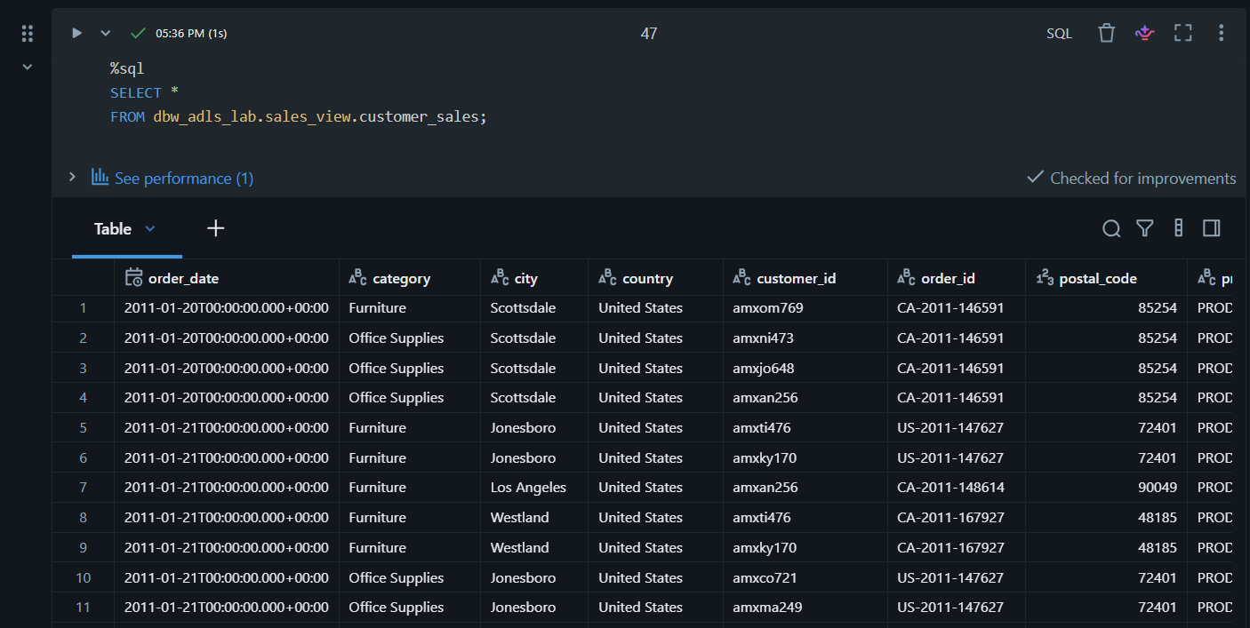
9. In gold layer
- using product and store table get the below data
store_id,store_name,location,manager_name,product_name,product_code,description,category_id,price,stock_quantity,supplier_id,product_created_at,product_updated_at,image_url,weight,expiry_date,is_active,tax_rate.
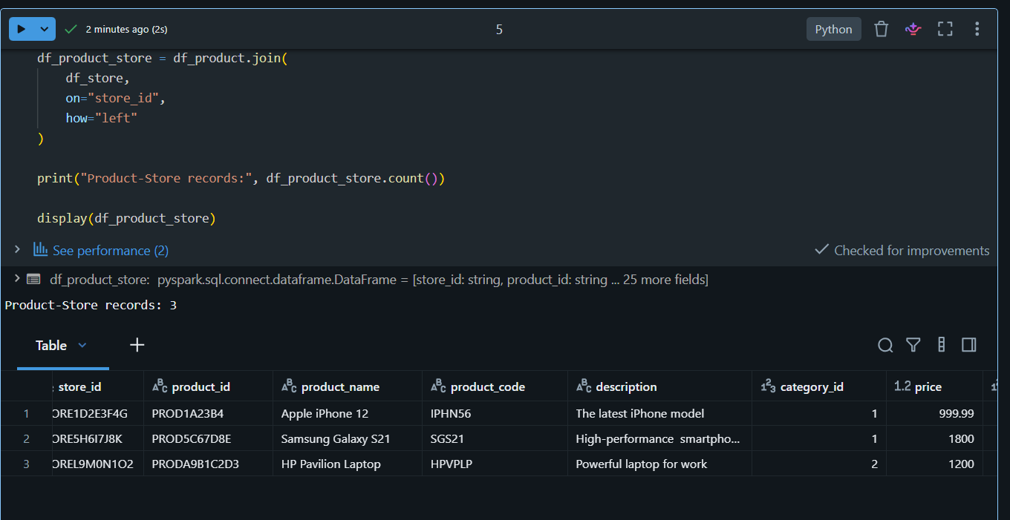
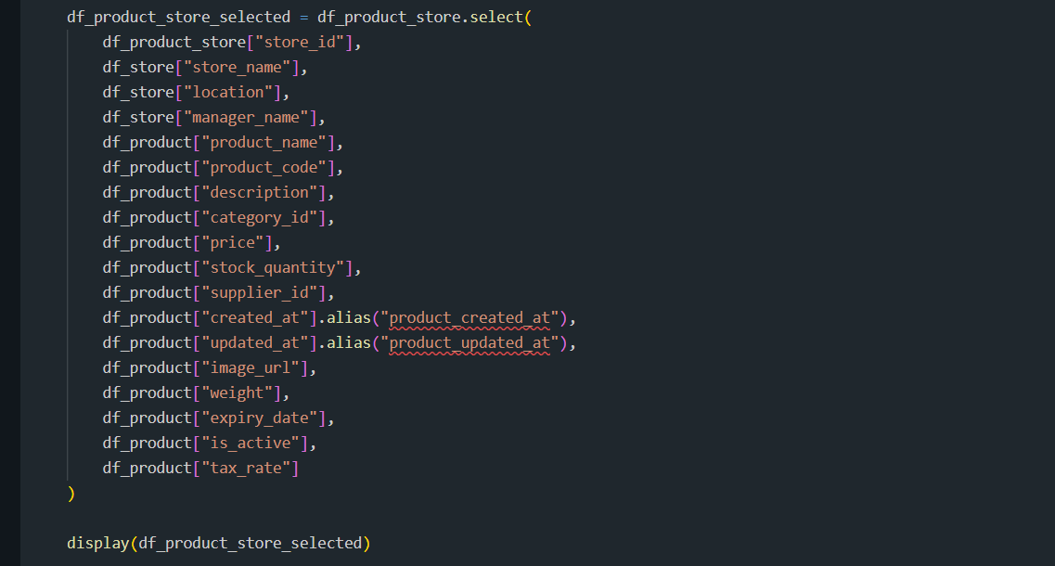
- Read the delta table (using UDF functions)
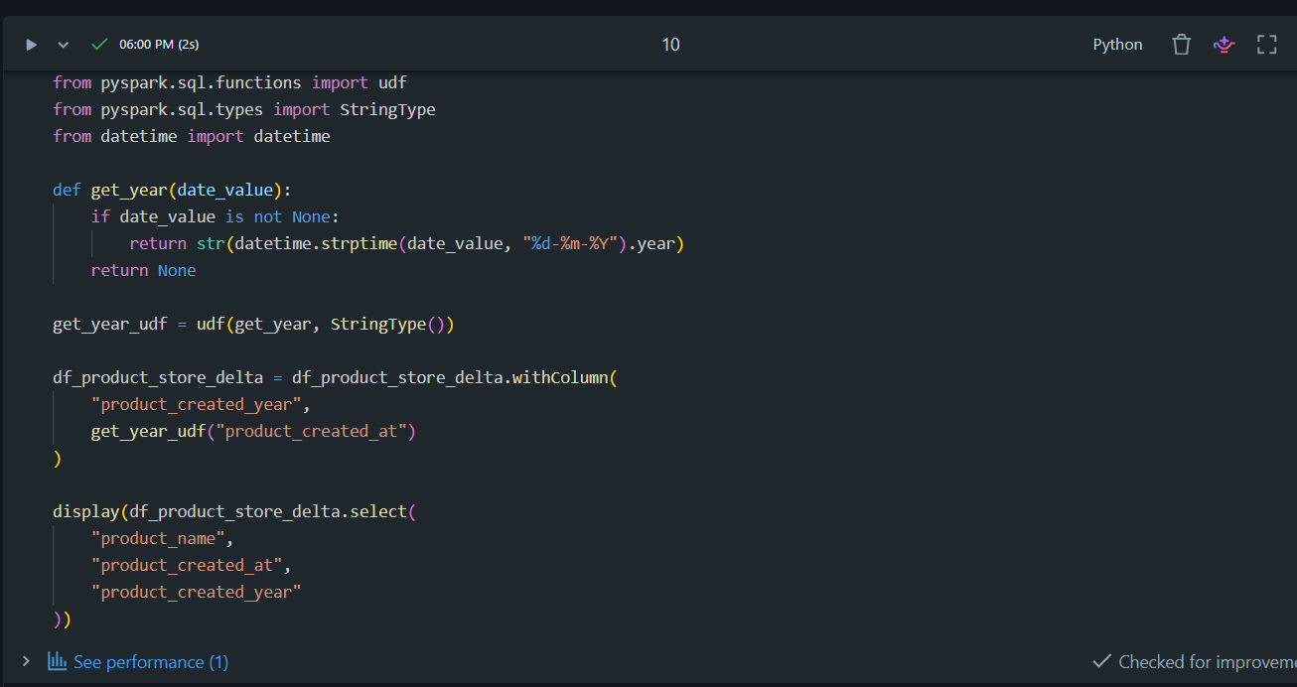

- Using the above data & customer_sales and get the below data
OrderDate,Category,City,CustomerID,OrderID,Product ID, Profit,Region, Sales,Segment,ShipDate,ShipMode,latitude,longitude,store_name,location,manager_name,product_name,price,stock_quantity,image_url
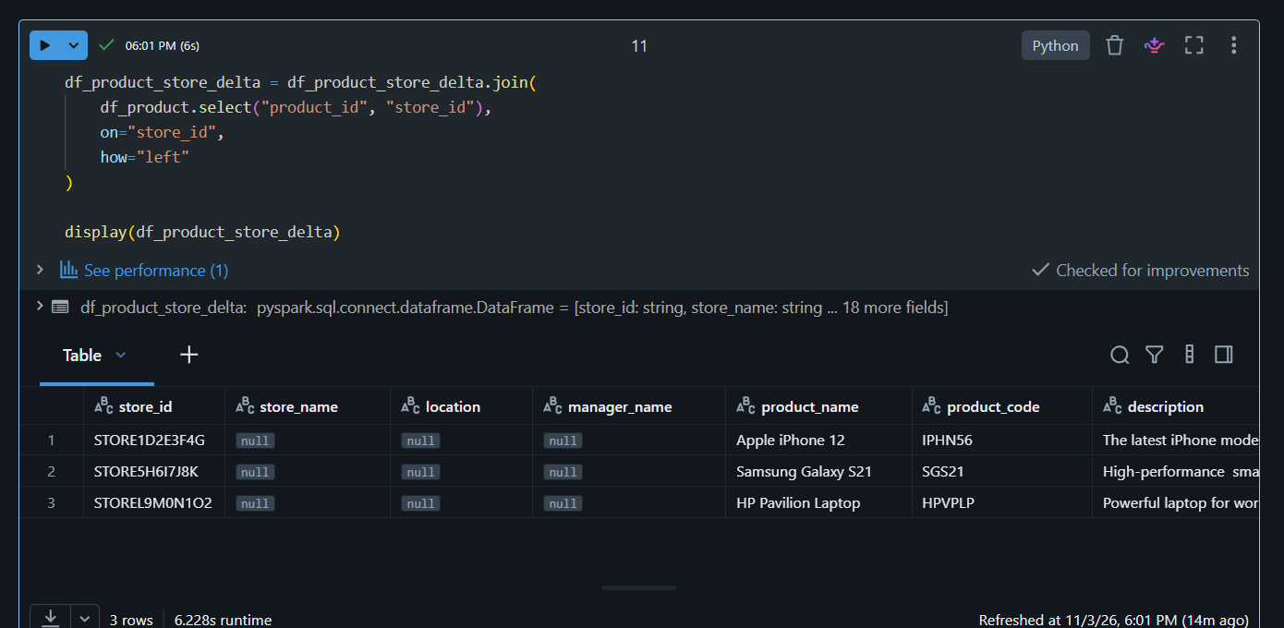
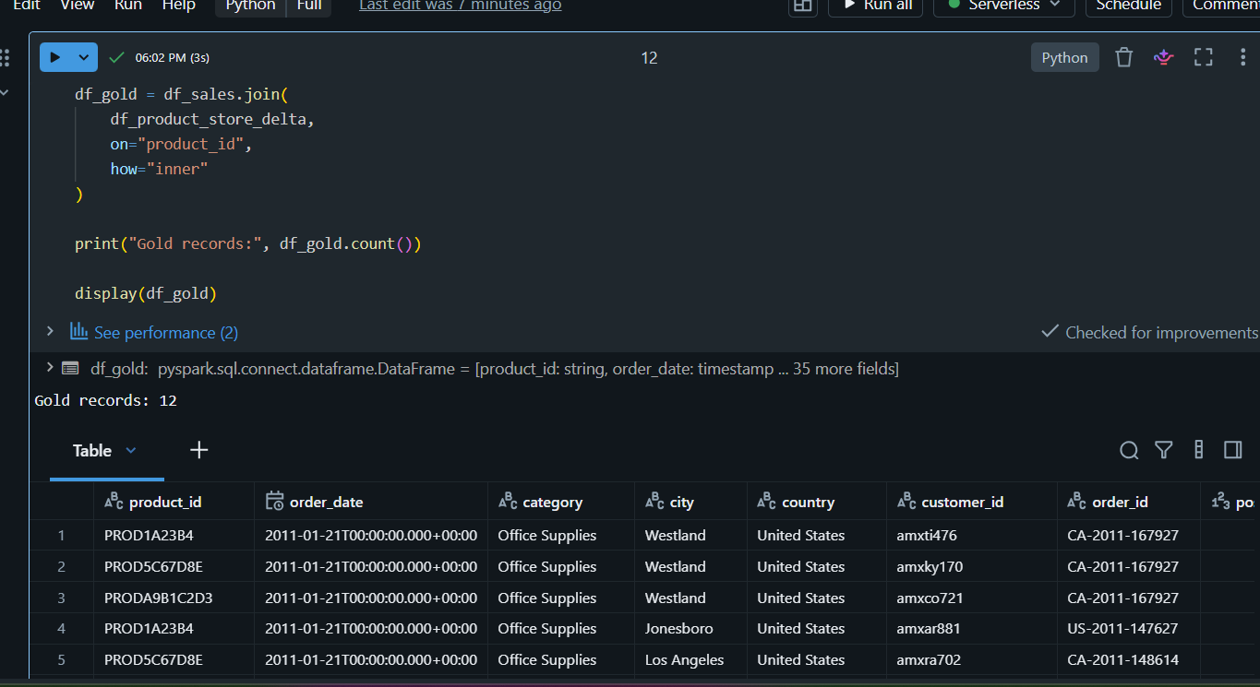
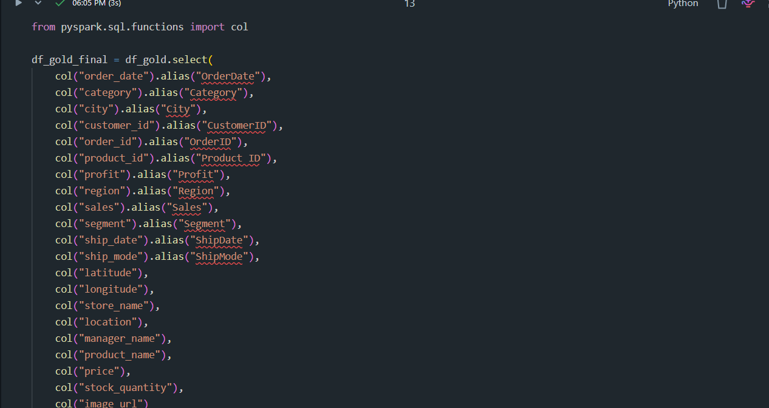

- Write based on overwrite (table_name : StoreProductSalesAnalysis )(in gold layer path is gold/sales_view/tablename/{delta pearquet}


